PRIMARY SETUP (PHYSICAL CONNECTIONS)

Presetup
Stack BoostPacks onto the LaunchPad (F28069M). There is only one way to stack them.
Download MATLAB R2023b + Simulink.

1. PSU
- Plug the 24V 5A PSU into the wall.
- Plug PIGTAILS into the PSU's DC barrel jack.
- Screw PIGTAILS into PVDD and GND.
- Ensure VDD+ is 24VDC and GND is GND; otherwise, the board will blow upon powering. Double-check with DMM as needed.
- If it helps, GND is always closest to the edge of the board.
- Use a jumper to connect VDD+ and GND from power board #1 to power board #2.
- 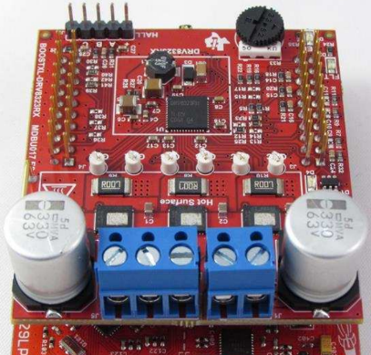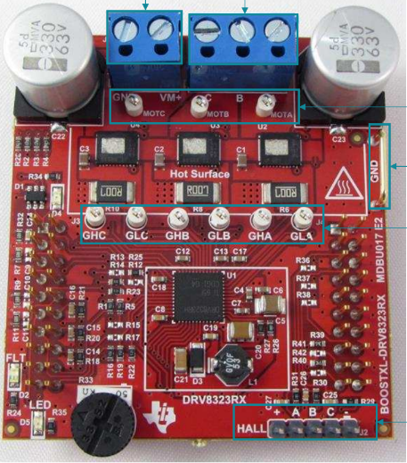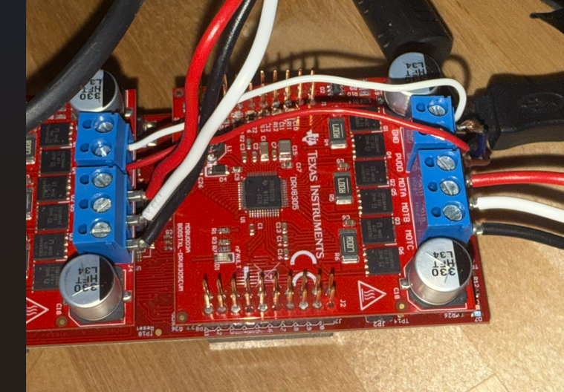

3-Phase Terminals
A-B-C
Input Power
VM+ COM
Phase Half-Bridge Power FETs
Filtering Capacitor
- See red and white jumpers in photo.

2. Encoder Connections
- J4 – the encoder female pins connect:
- For Motor #1 → J1–J4.
- For Motor #2 → J5–J8.
- 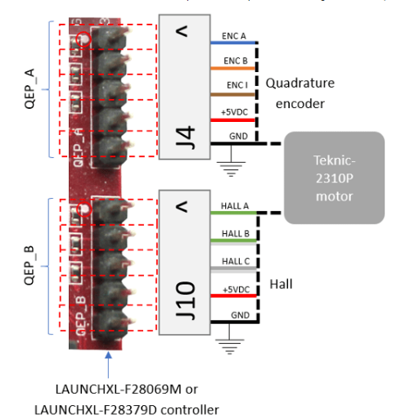
- Do NOT connect J10. Use J4 for both motors for the DYNO setup.

3. Motor Wiring
- Phase leads → blue terminals.
- Red → MOTA.
- White → MOTB.
- Black → MOTC.
- Green → GND → DNC.
- Capstone docs use different wiring; ignore and use this wiring.
- Ensure correct Motor # per board (Motor #1 connects to QEP_A and then MOTA, B, and C on power board #1. Motor #2 connects to QEP_B and then MOTA, B, and C on power board #2).
- See three phases in photo above for reference.
- Repeat for each motor on each BOOSTXL.

4. USB Link
Connect USB link to host computer.

5. Final Check
- Check polarity to mitigate failure.

Launch Instructions
See software setup instructions.

